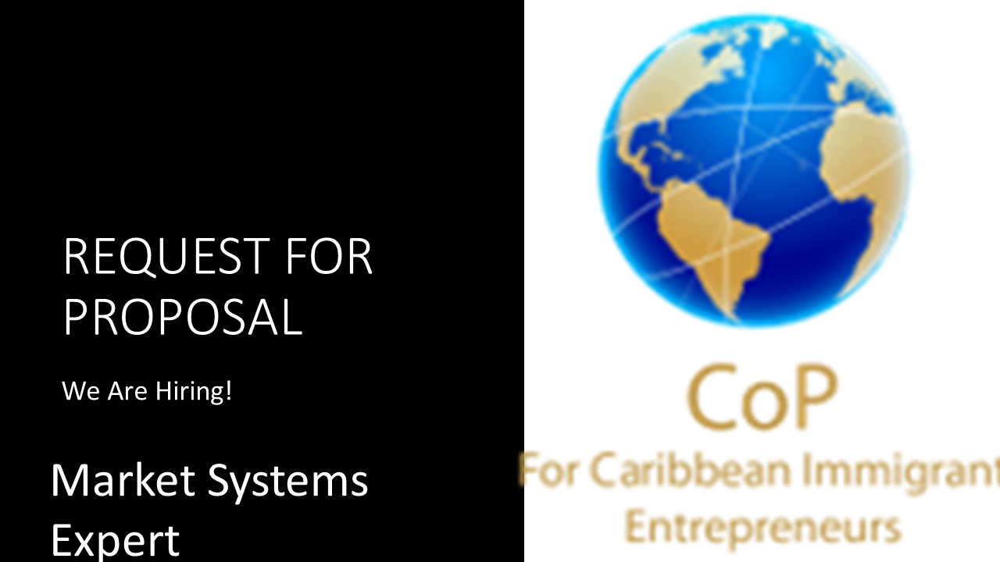

RFP−Market System Development Study
The Community of Practice for Caribbean Immigrant Entrepreneurs is soliciting proposals from qualified suppliers to deliver a “Market Systems Development Study for Identifying Opportunities in International Development for Diaspora Entrepreneurs”.
The study is intended to uncover market information asymmetry, markets that are underserved and recommendations for a follow-up solution in addition to ready information that can be leveraged by entrepreneurs so they might begin to explore those market opportunities.
Nice to have would be information related to diaspora consultants and service providers already in the space with whom entrepreneurs may partner for entering the market(s).
Besides sharing the findings at BIDEM Conference and Trade Show the consultant is expected to deliver a workshop on the study to The CoP, its funder and its audience.
The knowledge to be shared in the workshop should strengthen the quality of related advocacy, uncover market opportunities and areas of support for enabling more diaspora entrepreneurs to thrive in the international development space.

The workshop will be delivered virtually. Reports will be submitted electronically
Background
About The CoP

The Community of Practice for Caribbean Immigrant Entrepreneurs (CoP) is about mastery of entrepreneurship by Caribbeans in the diaspora and at home. It is that safe place where trust is built, collaborations, cooperation, friendships, and partnerships are forged― in a marketplace and research hub for delivering dynamic and inclusive entrepreneurship for and by Caribbeans.
It is where Caribbean entrepreneurs, their peers, and their businesses will draw on connections, knowledge, opportunities, and support to help them thrive and grow. The CoP is a coming together of entrepreneurs, researchers, entrepreneur support partners, funders, and in some instances industry for learning, sharing, collaborating, cooperating, co-creating, selling, knowledge building, resource mobilization, and skills share in the area of Caribbean Entrepreneurship, the entrepreneurship of other member peers, and success strategies for our immigrant entrepreneurs.
It is a CoP + MarketPlace that is also known as the High Performance Entrepreneurs Ring.

About the Proposed Study and Report
The CoP has received funding through the Supporting Black Canadian Communities Initiative (SBCCI) for delivering the session in support of strengthening the capacity of group under discussion.
The study and workshop are scheduled for completion by February 2021. However, preliminary findings and information on the markets are expected by October for sharing during BIDEM 2021 to be held October 13-15.
Proponents are invited to submit their fees, proposed study outline and availability.
Deliverables will include a copy of the study report and two speaker sessions where findings are shared with audiences of The CoP.
Submission deadline: June 20, 2021
Proposals should be submitted to : magate.wildhorse@gmail.com with the subject “Trade Impact Assessment Workshop”
We thank all proponents, however, only those under consideration will be contacted. No enquiries please.

